Walk 38 Stoke Prior
Last walked in June 2018

Description. A 8 km (4.9 mile) walk along narrow roads, across cropped fields and good looking farmland.
Start. Explorer Map 202 Grid 520565, by the side of the road.
Direction from Whitecross roundabout (Turn milometer to zero). Take the A4110 Canon Pyon (Three Elms road) for 1 mile and TR at the traffic lights onto the A4103 to Worcester (Roman road). Turn L at the first roundabout (2 mile), onto the A49 to Leominster. At 9.5 miles you go straight across the next roundabout towards Shrewbury on the A49. At 10.5 miles TR on a minor road to Stoke Prior. At 11.8 miles, TR into Stoke Prior church, (might need to open church gates).

1. Stoke Prior Church. (St Luke's, Stoke Prior, is a Victorian church, Grade 2* listed, which replaced an earlier Norman edifice demolished in the early 1860s). Walk down to the road and TR. Continue along the road. Ignore the first road off to the L that’s going to Leominster and continue on towards Humber. Continue up the road for about a kilometre, ignoring the next road off to the L, ‘Unsuitable For Heavy Goods Vehicles’, to TL by the national speed limit signs and head for Stoke Prior School. Go straight across the crossroads and on to Humber, along a no thru road. On your way you cross a river bridge, (HCC 483) and pass St Mary the Virgin, Humber church that is on your R. Ignore the turning L for Humber Court Farm (directly opposite the church lynch gate), and just before you get to Cider Mill, TR by a public footpath that goes thru a metal gate and along an enclosed track. At the end of the enclosed track (ignoring any gates L or R), go thru a metal gate into F1 and continue along the R field edge. About 100m along the field edge you go thru a new metal gate and into F2, and continue in the same direction but with the hedge now on your L. In the field corner you go thru a metal gate/stile into F3 and continue in the same direction, this time with the hedge on your R. You pass a disused brick cottage (L) as you proceed to the end of the field and cross over a gated metal footbridge into a wooded area. TR, and follow a track a short distance thru woods (stream is on your R), to cross a stile out of the woods and continue in the same direction across F4. Go thru a wooden gate into a grassy area, and continue past Risbury Mill (L) to cross over a stile onto a road, where you TR.

2. Risbury Bridge. (HCC 58 1936) Walk along the road for a few hundred metres to TL onto an enclosed bridleway to Hollywell Farm. Just before the farm you TR and go thru a small wooden/metal gate into F5 and walk along the L hand edge. At the end of the field you go thru a small metal gate into F6 and continue in the same direction, with the hedge on your L. At the end of this field you go thru a gap and continue in the same direction along a wide farm track, the hedge is now on your R. Just past a wooden electricity pylon, and when the farm track bends R, you continue in the same direction, straight across a cropped field and towards the L side of a copse. On reaching the L side of the copse you continue on along a grassy enclosed track, to reach a road, where you TR. Walk along the road and after about 100m, (at the end of the copse on your R), you TL and go thru the first metal gate (waymarked) and into F7. Continue along a public footpath along the R field edge (hedge is on your R), heading towards a white cottage with Solar panels on its roof (Little Wickton). At the end of the field continue straight on, passing to the R of Little Wickton cottages

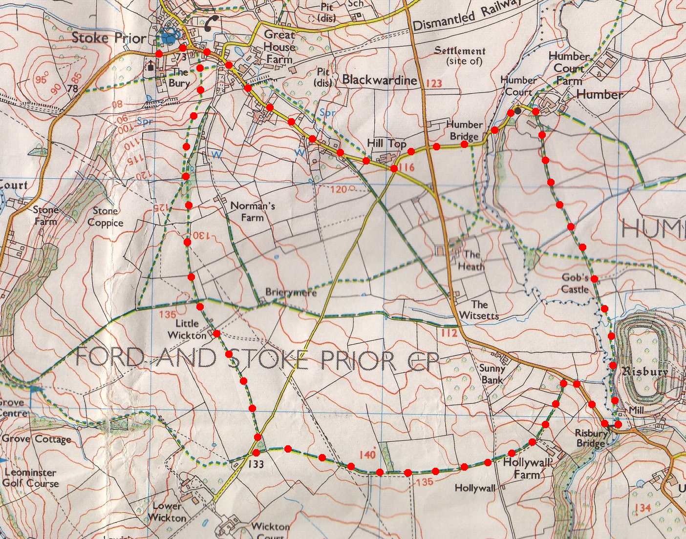
3. Little Wickton. Continue in the same direction thru F8, keep to the hedge on your L, to go thru a metal gate in the field corner and into F9, the fence/hedge is now on your R. Cross a stile/metal gate into F10, and continue on in the same direction, the hedge is on your R. Cross a stile and go straight across F11, ignoring any waymarker indicating to go off to the R. Go thru a metal gate into F12 and bear slightly R as you cross this field to go over a stile into F13. Bear slightly R as you cross this field and cross another stile into F14. Initially you will go steeply down hill to go thru a kissing gate and down an enclosed track to reach tarmac driveway. Continue on to the road and TL, continue along road toward the church and the car.
1
3
2

